**CICD pipeline using Code-commit and Code-pipeline and Elastic Bean Stalk**

**Step-1:**

Open Elastic Bean Stalk and Create a Application

Create a Environment to host website. Here , I choose Node.js environment.

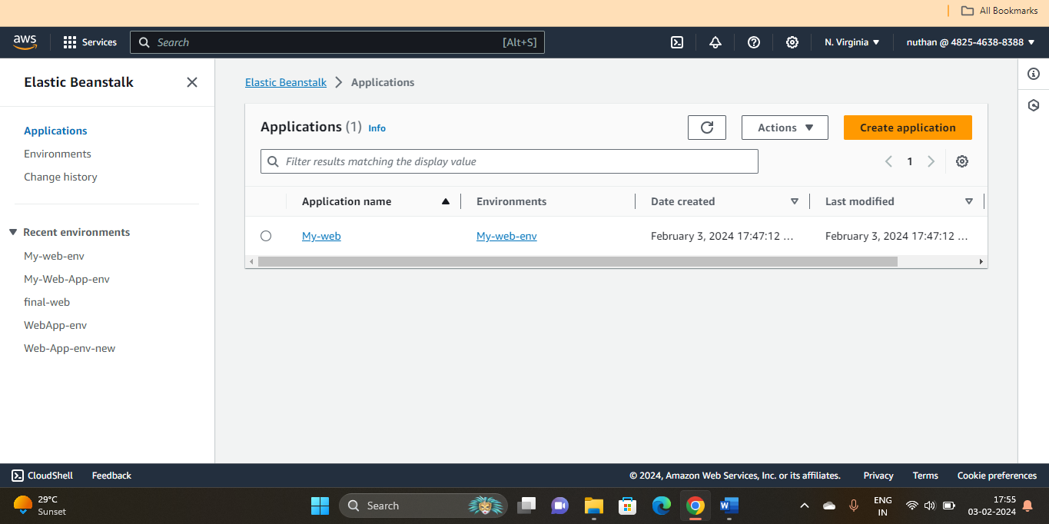

The above image showing creation of Application in Bean stalk

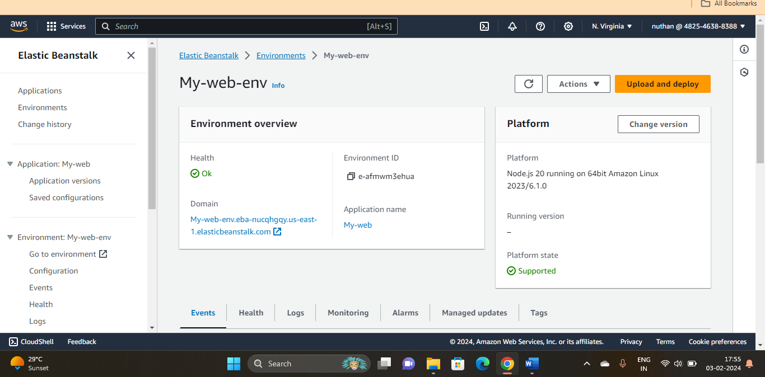

The above image showing environment created to host application in elastic bean stalk

Before deploying pipelined application , sample node.js application is deployed into elastic bean stalk , below is the image for that.

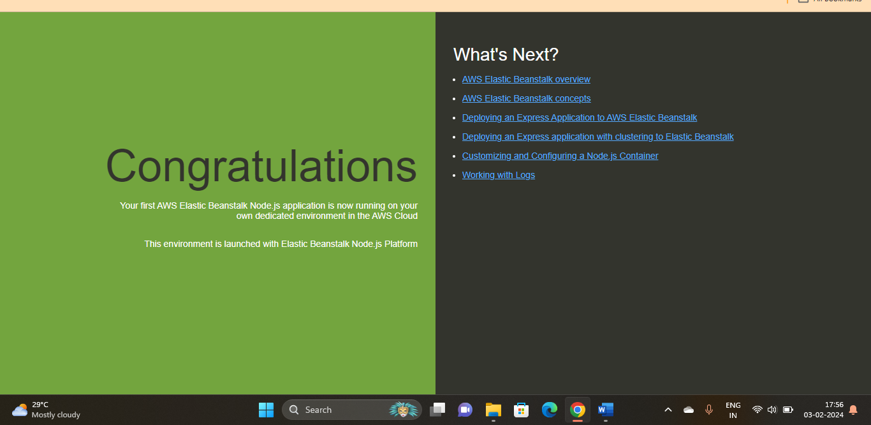

**Step-2:**

Open Code-commit and create a Repo

Add required files and dependencies into repo

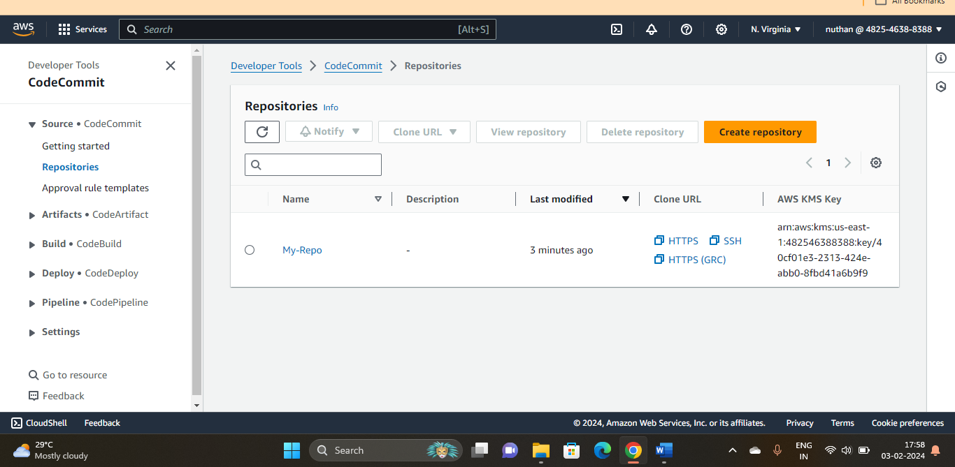

The above image shows, Creation of repo in Code-Commit

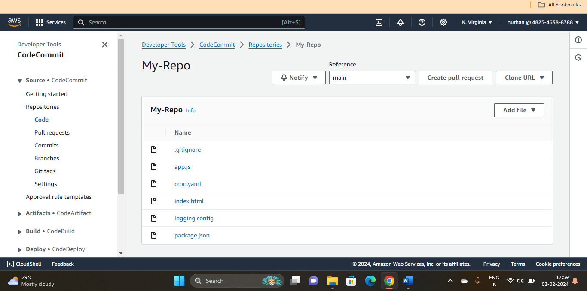

The above image shows adding files in repo

**Step-3:**

Open Code-pipeline and create a pipeline

In pipe line choose , source as code commit and deployment environment as Beanstalk.

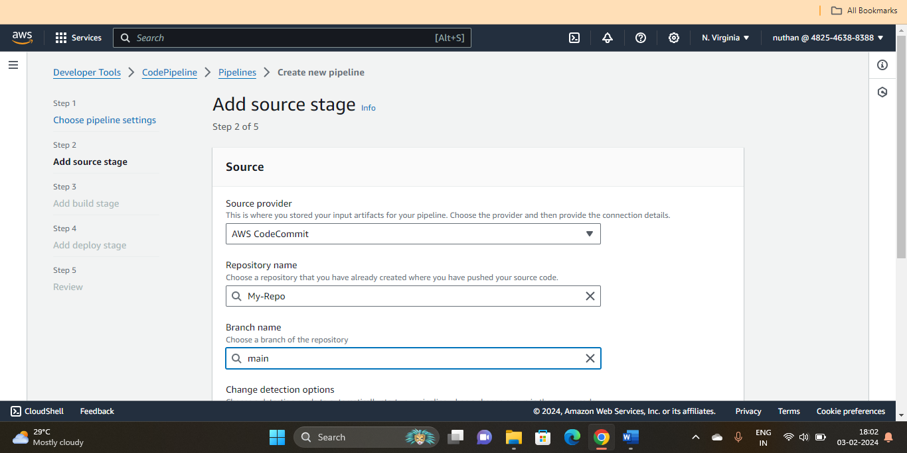

Adding source to CICD pipeline

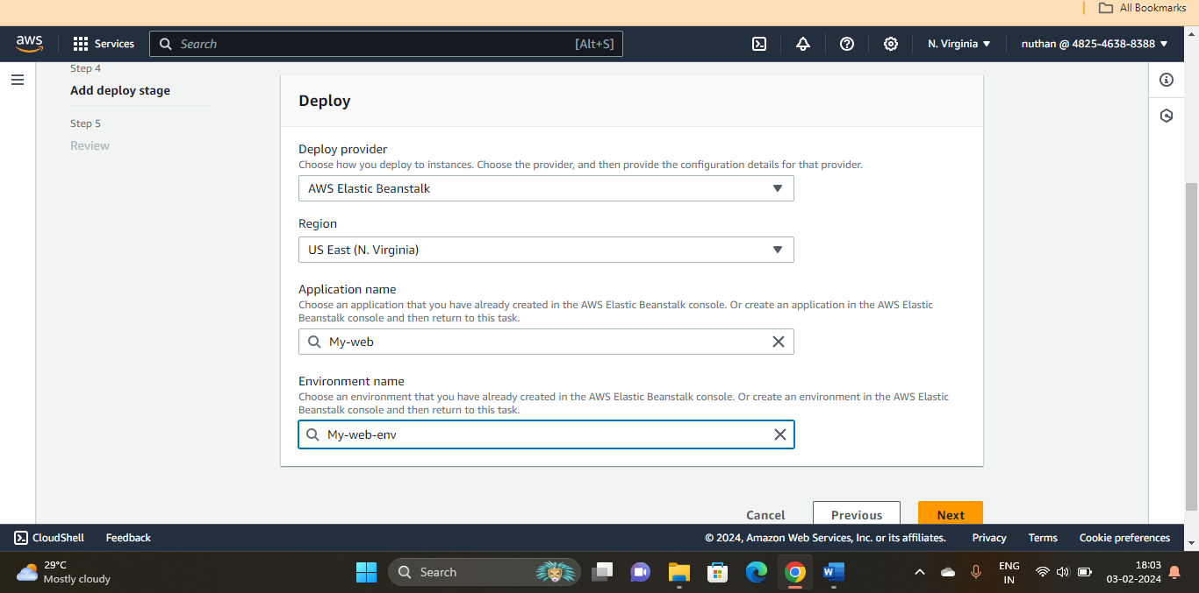

Adding Deployment environment as bean stalk to the pipeline

**For this demo purpose I have skipped build state.**

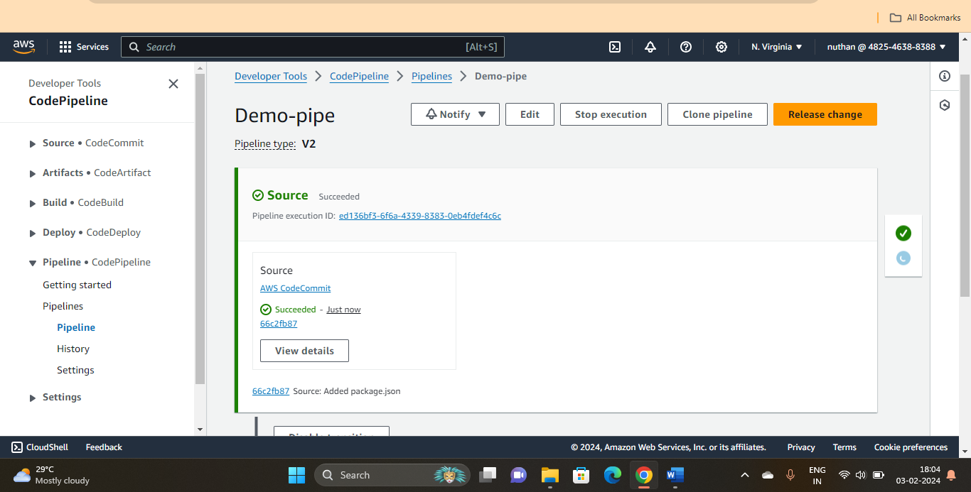

After successful creation of code pipeline , it shows like that

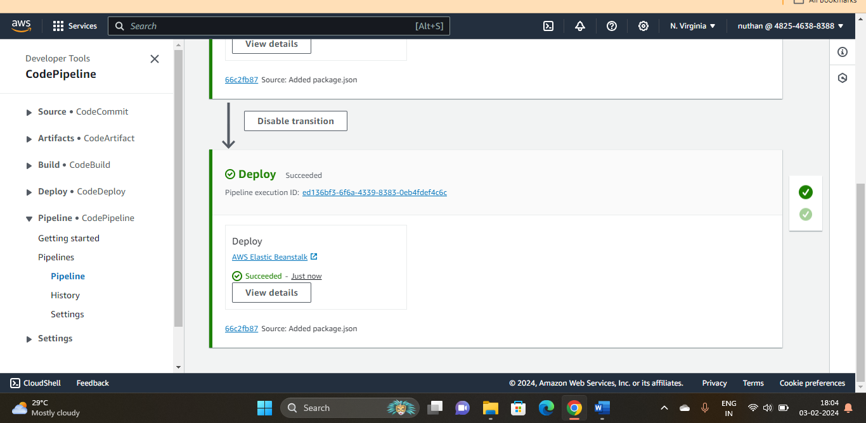

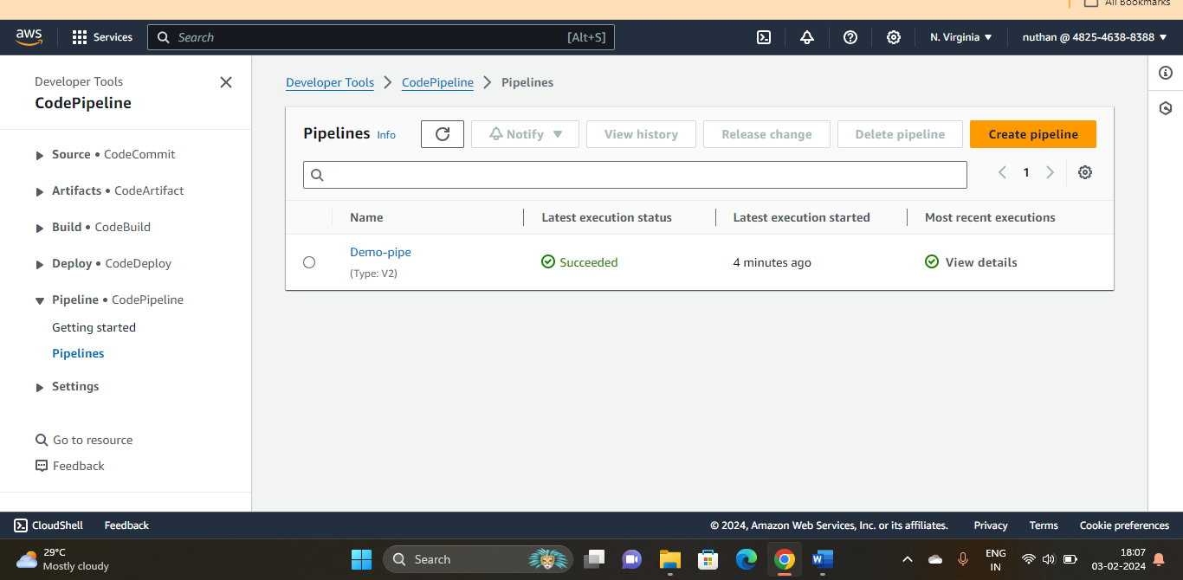

After successfully creating pipeline , the deployed environment is below.

